**CS3642 Programming Assignment #3 (Fall 2023)**

**Due: November 20, 2023 (11:30PM)**

**To implement two perceptrons that can** **perform the classification tasks of 1) and 2) below, respectively.**

**Requirement:**

1. **You must have a biased neuron in the input layer. Remember that we have 16 samples available. You may divide them into some for training and some for testing.**

Implement the perceptron to recognize 4 blocks image (such as one image shown below) to make a decision if an image is BRIGHT or DARK. Remember that we have 16 samples for the input.

* + If it contains 2, 3 or 4 white pixels, it is “**bright**”
  + If it contains 0 or 1 white pixels, it is “**dark**”

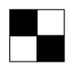

1. **Design a new perceptron for real-world applications of your own choice, NOT toy examples such as AND Boolean function. Your design must be shown on your PDF file.**

You may write your code in a contemporary language of your choice; typical languages would include C/C++, Python, Java, Ada, Pascal, Smalltalk, Lisp, and Prolog. A GUI interface is required.

1. Submit a PDF file of your well-commented source program, your perceptron architecture and your printed outputs (screen shots). Please include your codes in your PDF file. It is plagiarism to take codes from the website. Try to understand the algorithm and implement the algorithm by your own.
2. Provide a video presentation of your programming assignment in MP3/MP4 or YouTube.
3. Please upload 1) and 2) separately to D2L.
4. Restriction: No zipped files.

Adding the following sections at the beginning of your PDF including your code and outputs.

**I: Your information.**

|  |  |
| --- | --- |
| // Course: | Artificial Intelligence |
| // Student name: | Raehyeong Lee |
| // Student ID: | 000996758 |
| // Assignment #: | 3 |

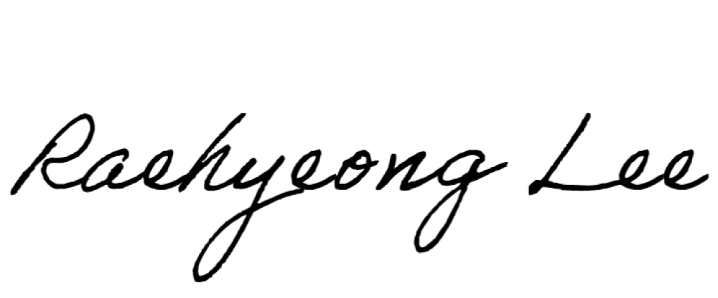// Due Date: 2023 Nov.20

// Signature: ______________(Your signature assures that everything is your own work. Required)

// Score: ______________(Note: Score will be posted on D2L)

II: Your perception architecture for a real-world application. Please briefly explain. \

1. First requirement

import numpy as np

def train_perceptron(inputs, labels, learning_rate=0.1, epochs=1000):

    input_size = len(inputs[0])

    weights = np.random.rand(input_size)

    bias = np.random.rand()

    for epoch in range(epochs):

        for i in range(len(inputs)):

            predicted = predict(inputs[i], weights, bias)

            error = labels[i] - predicted

            weights += learning_rate * error * np.array(inputs[i])

            bias += learning_rate * error

    return weights, bias

def predict(inputs, weights, bias):

    summation = np.dot(inputs, weights) + bias

    return 1 if summation > 0 else 0

def classify_brightness(images):

    inputs = [

        [1, 1, 1, 0],

        [1, 1, 0, 0],

        [1, 0, 0, 0],

        [1, 0, 1, 0],

        [0, 1, 1, 0],

        [0, 1, 0, 0],

        [0, 0, 0, 0],

        [0, 0, 1, 0],

        [1, 1, 1, 1],

        #[1, 1, 0, 1],

        #[1, 0, 0, 1],

        #[1, 0, 1, 1],

        #[0, 1, 1, 1],

        #[0, 1, 0, 1],

        #[0, 0, 0, 1],

        #[0, 0, 1, 1],

    ]

    labels_bright = [1, 1, 0, 1, 1, 0, 0, 0, 1, '''1, 0, 1, 1, 0, 0, 0''']

    weights_bright, bias_bright = train_perceptron(inputs, labels_bright)

    results = []

    for image in images:

        results.append(predict(image, weights_bright, bias_bright))

    return results

test_images = [

    [1, 1, 1, 0],

    [0, 0, 0, 1],

    [1, 0, 0, 0],

    [1, 1, 1, 1],

]

brightness_results = classify_brightness(test_images)

print("Brightness Classification Results:", brightness_results)

print("Actual Brightness Classification:  [1, 0, 0, 1]")

Output 1 Output 2

1. Second Requirements

import numpy as np

class Perceptron:

    def __init__(self, input_size):

        self.weights = np.random.rand(input_size)

        self.bias = np.random.rand()

    def predict(self, inputs):

        summation = np.dot(inputs, self.weights) + self.bias

        return 1 if summation > 0 else 0

def fingerprint_recognition():

    perceptron = Perceptron(input_size=10)

    # Fingerprint data

    training_data = [

        (np.array([1, 0, 1, 0, 1, 0, 1, 0, 1, 0]), 1),

        (np.array([0, 1, 0, 1, 0, 1, 0, 1, 0, 1]), 0),

        (np.array([1, 1, 1, 0, 0, 0, 1, 1, 1, 0]), 1),

        (np.array([0, 0, 0, 1, 1, 1, 0, 0, 0, 1]), 0),

        (np.array([1, 1, 0, 0, 1, 1, 0, 0, 1, 1]), 1),

        (np.array([0, 0, 1, 1, 0, 0, 1, 1, 0, 0]), 0),

        (np.array([1, 0, 0, 0, 1, 0, 0, 0, 1, 0]), 1),

        (np.array([0, 1, 1, 1, 0, 1, 1, 1, 0, 1]), 0),

    ]

    epochs = 1000

    learning_rate = 0.1

    for epoch in range(epochs):

        for inputs, label in training_data:

            prediction = perceptron.predict(inputs)

            error = label - prediction

            perceptron.weights += learning_rate * error * inputs

            perceptron.bias += learning_rate * error

    # Testing

    test_data = [

        (np.array([1, 0, 1, 0, 1, 0, 1, 0, 1, 0]), "My Right Thumb fingerprint"),

        (np.array([0, 1, 0, 1, 0, 1, 0, 1, 0, 1]), "Rick's fingerprint"),

        (np.array([0, 0, 1, 1, 0, 0, 1, 1, 0, 0]), "Morty's fingerprint"),

        (np.array([1, 1, 1, 0, 0, 0, 1, 1, 1, 0]), "My Right Thumb fingerprint"),

        (np.array([1, 1, 0, 1, 1, 1, 0, 0, 1, 0]), "My Left Thumb  fingerprint"),

        (np.array([1, 0, 0, 1, 1, 0, 0, 0, 1, 0]), "My Left Thumb  fingerprint"),

        (np.array([0, 1, 1, 1, 0, 1, 1, 1, 0, 1]), "Tom's fingerprint"),

        (np.array([0, 0, 0, 1, 1, 1, 0, 0, 0, 1]), "Jerry's fingerprint"),

    ]

    print("Finger Print Result:")

    for inputs, pattern_name in test_data:

        result = perceptron.predict(inputs)

        if result == 1:

             print(f"{pattern_name}: Phone unlocked.")

        else:

            print(f"{pattern_name}: Fingerprint does not Match.")

if __name__ == "__main__":

    fingerprint_recognition()

Output 1 Output 2 Output 3

